What Is Co-Ownership & a Breeding Agreement?

Breeders enter into co-ownerships when they have an interest in breeding a dog, but for one reason or another decide not to keep the dog.

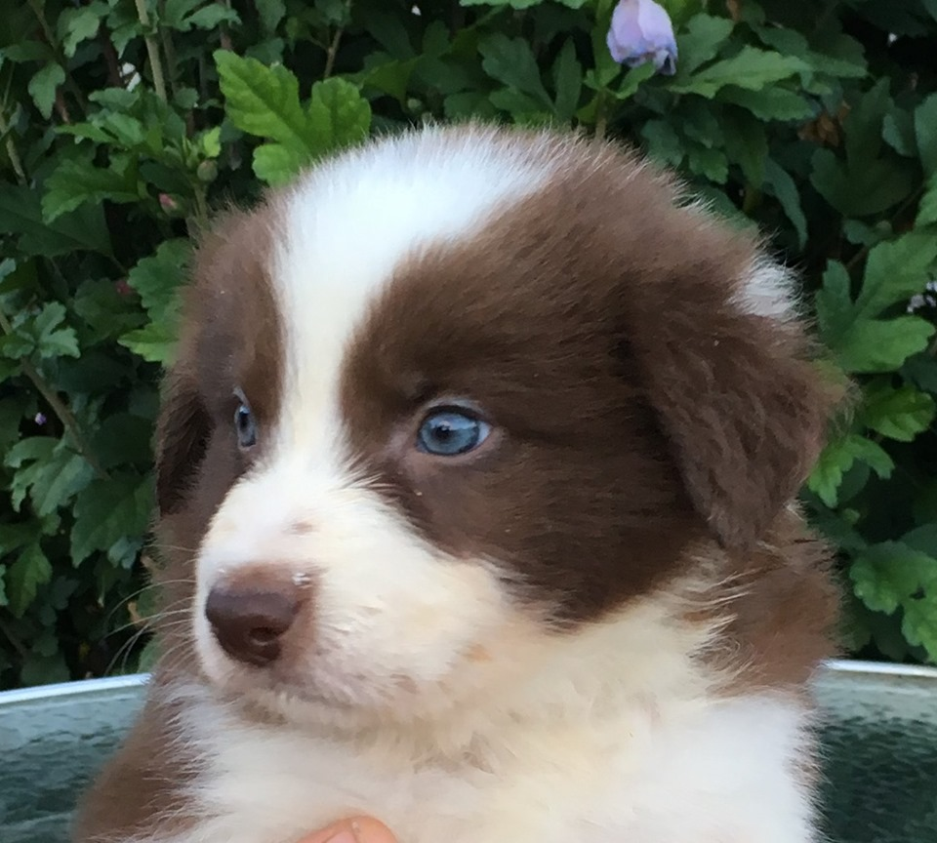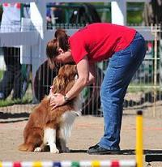

What is a co-ownership?
Technically it means that both the owner and breeder will be listed on the dog’s registration papers as owners. Despite being called a co-ownership the “owner” of the dog will indeed be the owner and the breeder will only be involved in the breeding aspects of the dog.

Why would an owner enter into an agreement such as this? This is not for everyone, but there are some advantages to the owner. The owner will get the fun of being involved with breeding and getting to see their own dog’s puppies without any responsibility for raising the puppies or finding proper homes for them. The breeder will look after everything to do with the litter. Other benefits include complete health clearances paid for by the breeder (hip, elbow certification, eye clearances, DNA tests etc.). Also the owner will be reimbursed for any inconveniences of having the litter or they can choose to keep a puppy from the litter. Another advantage is that the owner will have a great opportunity to learn more about breeding dogs and the dog world.

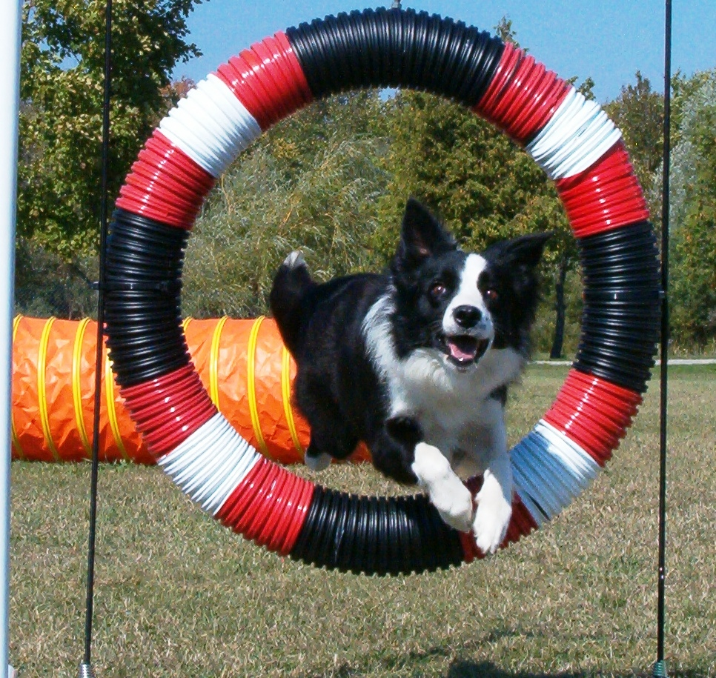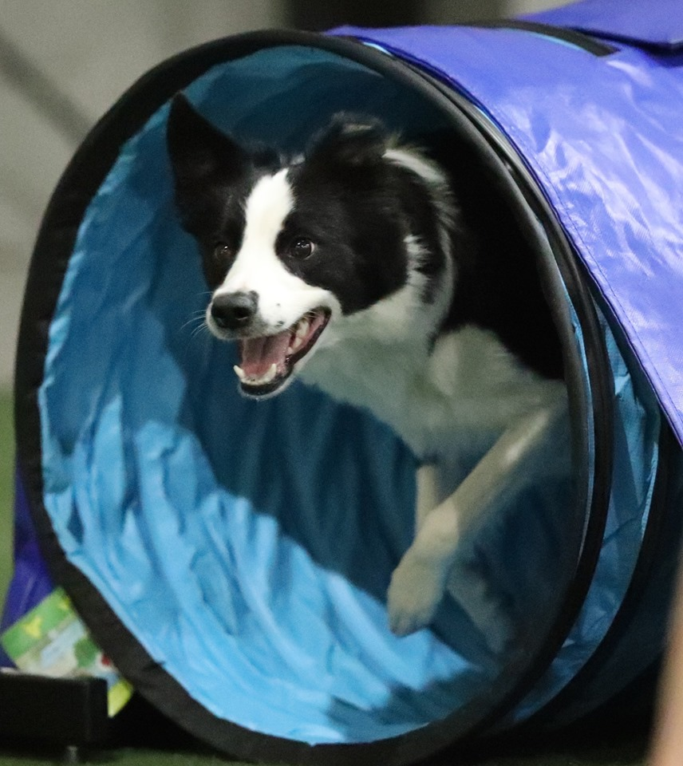

What are the disadvantages? There are disadvantages too. Since the female will not be spayed she will have heat cycles, usually every 6 to 8 months. During this time she will have a bloody discharge for about 5 to 10 days. After that she will have a receptive period of time lasting 2 to 10 days. During this time she could be bred and become pregnant so it is important to make sure that she does not come into contact with any male dogs. Dogs that are in heat may not be allowed to compete in performance events (this is changing, many dog sports now allow dogs to compete while in heat) so heat cycles may interfere with trialing plans. Also for the last 30 days of pregnancy the dog’s activities may need to be somewhat curtailed if she is training or trialing particularly intensively. The dog will be living with the breeder for a period of time (usually 5 to 6 weeks) while she gives birth and nurses the puppies. It can be hard to part with your dog for this length of time. There is also some risk to the dog involved with breeding, pregnancy and giving birth. She could have complications or require a caesarian section, while these are not common, it is possible.
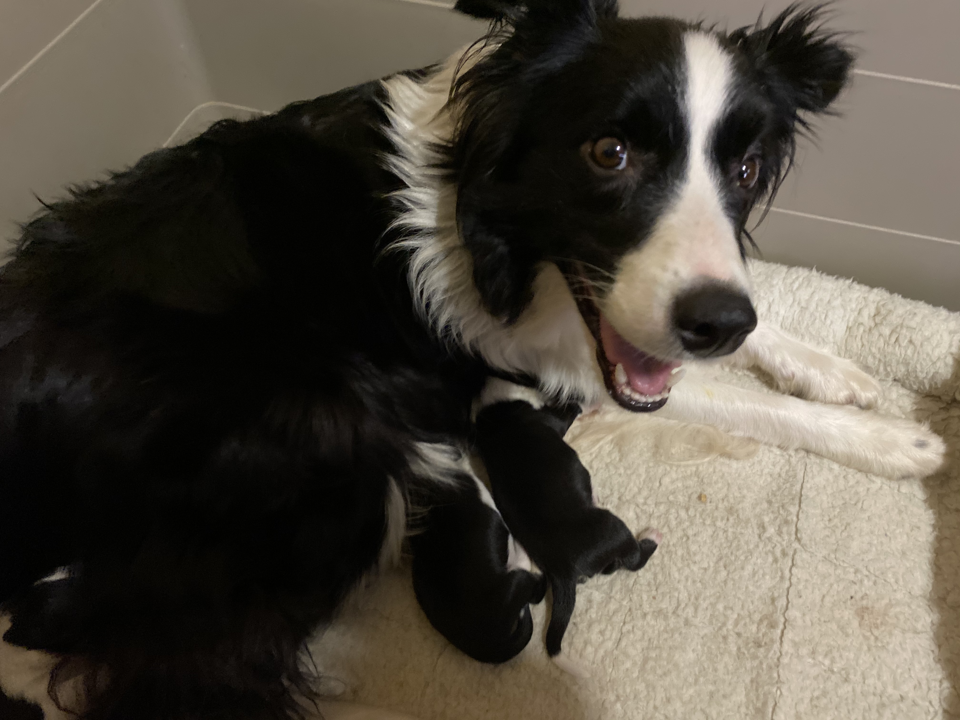

How often would the dog be bred? This depends. If the breeder really likes the dog and there is a lot of interest in her puppies she may be bred more frequently. Under no circumstance would she be bred before she is 2 years old and likely would not be bred more than once every year or two. It is likely that she would be bred no more than three times although it is possible.

What if my plans conflict with the breeders breeding plans? It is possible that you may wish to enter an important trial or other event just when the breeder wishes to breed the dog. It is important to discuss this with the breeder. The breeder should not make such demands on your dog’s schedule that you cannot enter important competitions, likewise it is incumbent on the owner to give the breeder reasonable access to the dog for breeding purposes.




